CS 255 System Design Document Template
This template lays out all the different sections that you need to complete for Project Two. Each section has guidance to prompt your thinking. You will need to continually reference the interview transcript as you work to make sure that you are addressing your client’s needs. There is no required length for the final document. Instead the goal is to complete each section based on what your client’s needs are. Remove this note when you are finished, and replace all bracketed text with the relevant information.

UML Diagrams

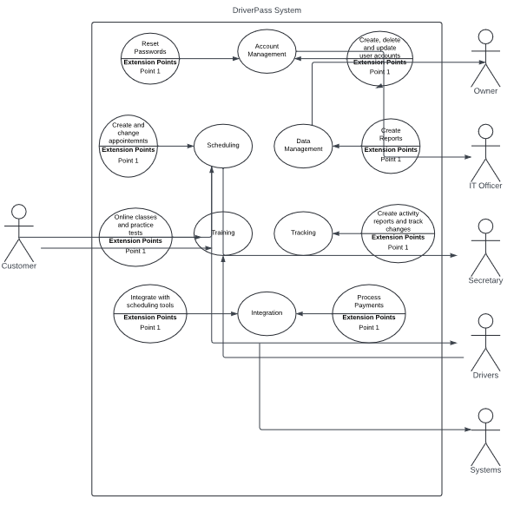

UML Activity Diagrams
- Generate Activity Report
- Make Reservation
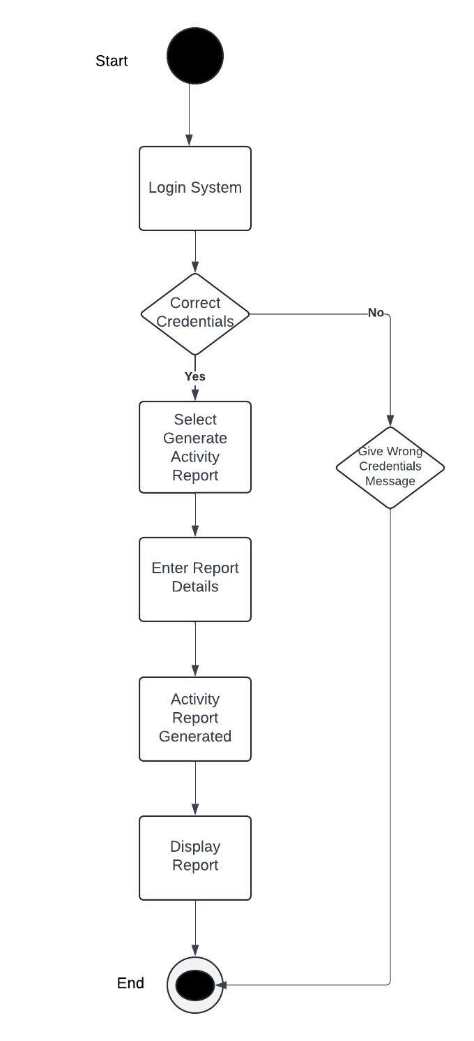
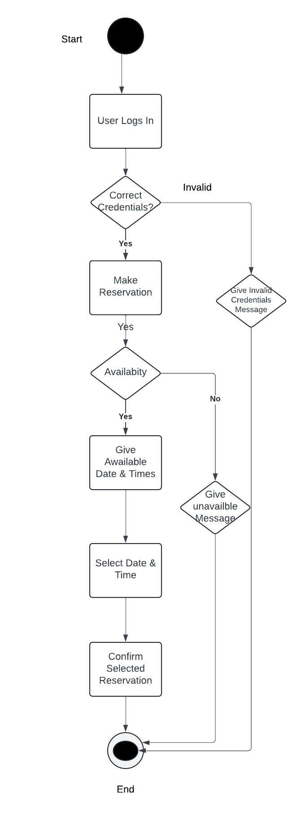

UML Sequence Diagram
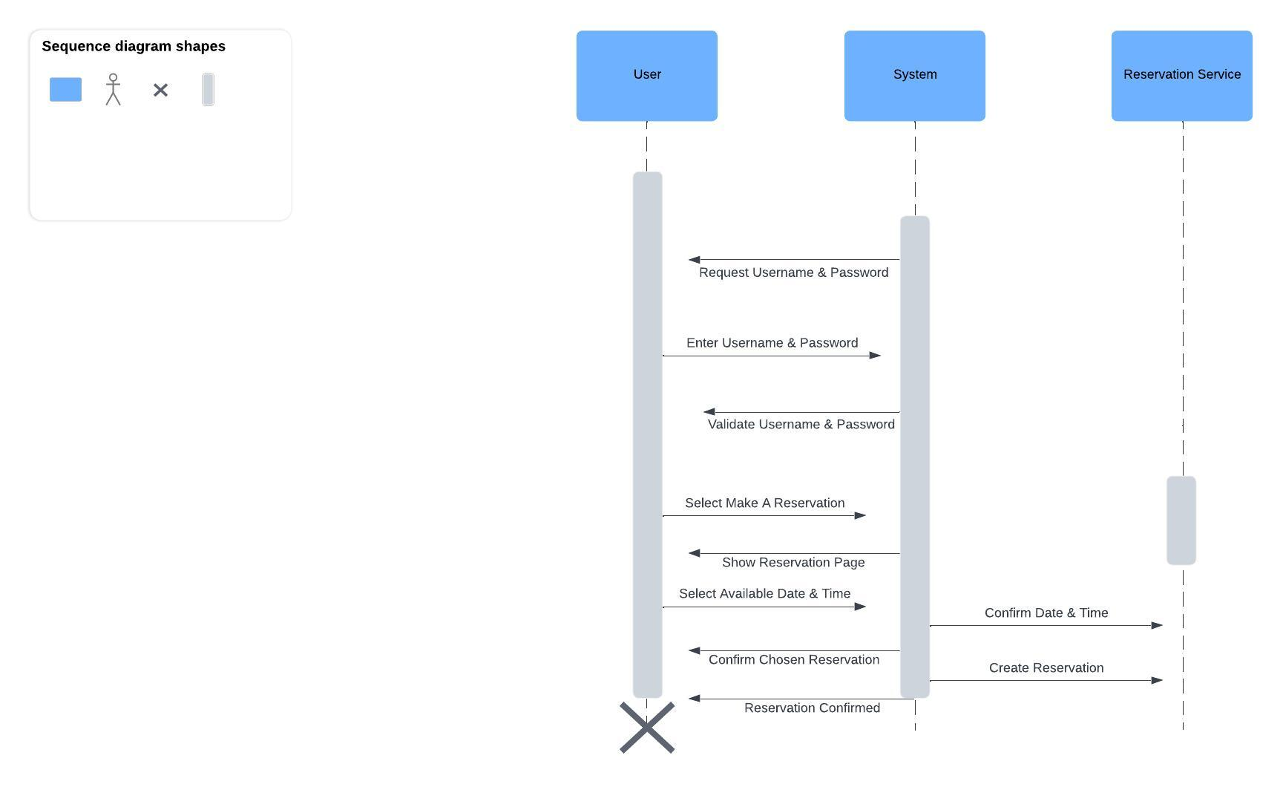

UML Class Diagram
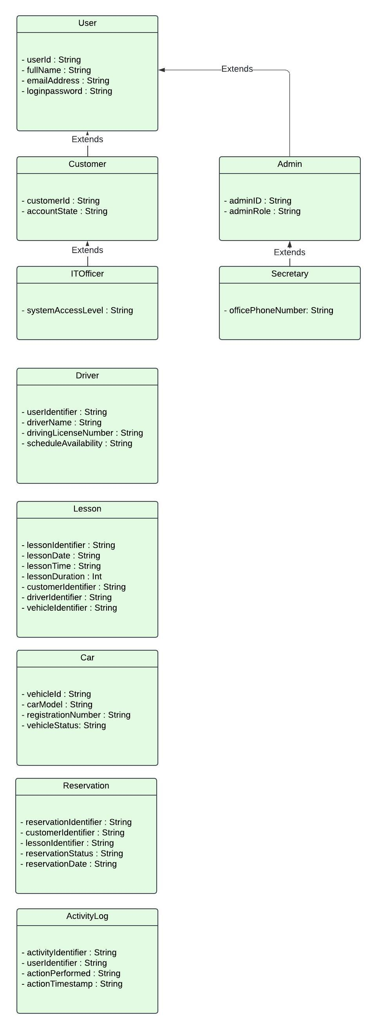

Technical Requirements
DriverPass's system design includes various technical requirements, such as hardware, software, tools, and infrastructure. To ensure smooth performance and reliability, we need robust servers to host the application and database. Additionally, we require enough storage capacity to handle user data, course materials, and transaction records. Reliable networking hardware, like routers and switches, is also crucial for seamless connectivity. For software, we need compatibility with Windows, Linux, and Unix for web applications, as well as with Android and iOS for mobile apps. Database management systems like MySQL, PostgreSQL, or MongoDB will handle user information, reservations, and course data, while web server software like Apache or Nginx will serve the web application.
API frameworks, like RESTful APIs, should be used to smoother communication between the front-end and back-end systems. For efficient coding, integrated development environments (IDEs) such as Visual Studio Code, Eclipse, or PyCharm are important. Version control systems like Git should also be used to manage code versions and facilitate collaboration.
To make sure that DriverPass runs smoothly and securely on different platforms, we need to use cloud hosting platforms like AWS or Google Cloud for scalability, flexibility, and reliability. It's also essential to have a content delivery network (CDN) to improve load times and efficiently deliver content worldwide. Additionally, we need security tools in place, such as SSL/TLS certificates for secure data transmission and firewalls for network security. These technical requirements meet both functional and non-functional needs, ensuring the efficient and reliable operation of DriverPass.

